Chapter 1. The Context of Data Visualization
This opening chapter provides an introduction to the subject of data visualization and the intention behind this book.
We start things off with some context about the subject. This will briefly explain why there is such an appetite for data visualization and why it is so relevant in the modern age against the backdrop of enhanced technology, increasing capture and availability of data, and the desire for innovative forms of communication.
After this introduction, we then look at the theoretical basis of data visualization, specifically the importance of understanding visual perception. To help establish a term of reference for the rest of the book, we'll then consider a proposed definition for this subject.
Next, we introduce the data visualization methodology, a recommended approach that forms the core of this book, and discuss its role in supporting an effective and efficient design process.
Finally, we consider some of the fundamental data visualization design objectives. These provide a useful framework for evaluating the suitability of the choices we make along the journey towards an accomplished design solution.
Exploiting the digital age
The following is a quotation from Hal Varian, Google's chief economist (http://www.mckinseyquarterly.com/Hal_Varian_on_how_the_Web_challenges_managers_2286):
The ability to take data—to be able to understand it, to process it, to extract value from it, to visualize it, to communicate it—that's going to be a hugely important skill in the next decades.
Data visualization is not new; the visual communication of data has been around in various forms for hundreds and arguably thousands of years. Popular methods that still dominate the boardrooms of corporations across the land—the line, bar, and pie charts—originate from the eighteenth century.
What is new is the contemporary appetite for and interest in a subject that has emerged from the fringes and into mainstream consciousness over the past decade.
Catalyzed by powerful new technological capabilities as well as a cultural shift towards greater transparency and accessibility of data, the field has experienced a rapid growth in enthusiastic participation.
Where once the practice of this discipline would have been the preserve of specialist statisticians, engineers, and academics, the globalized field that exists today is a very active, informed, inclusive, and innovative community of practitioners pushing the craft forward in fascinating directions. The following image shows a screenshot of the OECD 'Better Life Index', comparing well-being across different countries. This is just one recent example of an extremely successful visual tool emerging from this field.
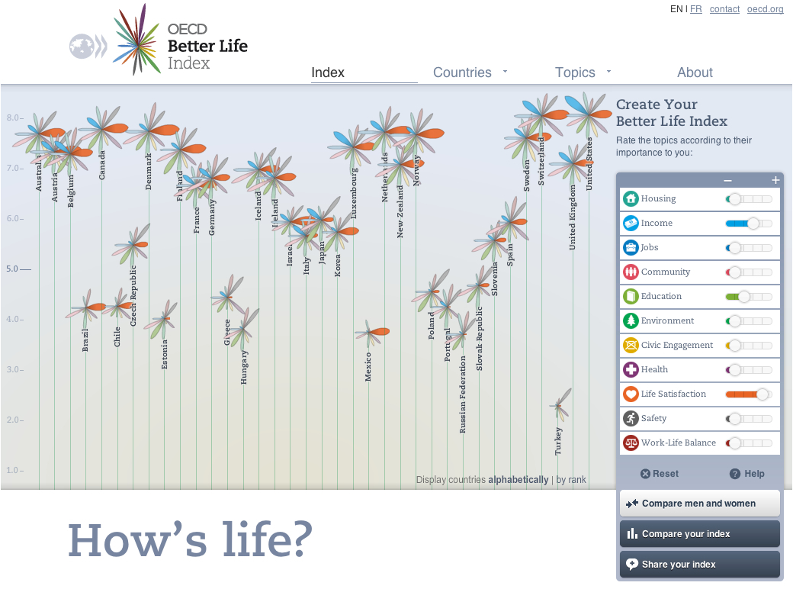
Image from "OECD Better Life Index" (http://oecdbetterlifeindex.org), created by Moritz Stefaner (htpp://moritz.stefaner.eu) in collaboration with Raureif GmbH (http://raureif.net)
Data visualization is the multi-talented, boundary-spanning trendy kid that has seen many esteemed people over the past few years, such as Hal Varian, forecasting this as one of the next big things.
Anyone considering data visualization as a passing fad or just another vacuous buzzword is short-sighted; the need to make sense of and communicate data to others will surely only increase in relevance. However, as it evolves from the next big thing to the current big thing, the field is at an important stage of its diffusion and maturity. Expectancy has been heightened and it does have a certain amount to prove; something concrete to deliver beyond just experimentation and constant innovation.
It is an especially important discipline with a strong role to play in this modern age. To help frame this, let's first look at the data side of things.
Take a minute to imagine your data footprint over the past 24 hours; that is, the activities you have been involved in or the actions you have taken that will have resulted in data being created and captured.
You've probably included things such as buying something in a shop, switching on a light, putting some fuel in your car, or watching a TV program: the list can go on and on.
Almost everything we do involves a digital consequence; our lives are constantly being recorded and quantified. That sounds a bit scary and probably a little too close for comfort to Orwell's dystopian vision. Yet, for those of us with an analytical curiosity, the amount of data being recorded creates exciting new opportunities to make and share discoveries about the world we live in.
Thanks to incredible advancements and pervasive access to powerful technologies we are capturing, creating, and mobilizing unbelievable amounts of data at an unbelievable rate. Indeed, such is the exponential growth in digital information, in the last two years alone, humanity has created more data than had ever previously been amassed (http://www.emc.com/leadership/programs/digital-universe.htm).
Data is now rightly seen as an invaluable asset, something that can genuinely help change the world for the better or potentially create a competitive goldmine, depending on your perspective. "Data is the new oil", first voiced in 2006 and attributed to Clive Humby of Dunnhumby, is a term gaining traction today. Corporations, government bodies, and scientists, to name but a few, are realizing the challenges and, moreover, opportunities that exist with effective utilization of the extraordinary volumes, large varieties, and great velocity of data they govern.
However, to unlock the potential contained within these deep wells of ones and zeros requires the application of techniques to explore and convey the key insights.
Flipping to the opposite side of the data experience, we also identify ourselves as consumers of data. As you would expect, given the volume of captured data, never before in our history have we been faced with the prospect of having to process and digest so much.
Through newspapers, magazines, advertising, the Web, text messaging, social media, and e-mail, our eyes and brains are being relentlessly bombarded by information. In a typical day, it is said we can expect to consume about 100,000 words (http://hmi.ucsd.edu/howmuchinfo_research_report_consum.php), which is an astonishing quantity of signals for us to have to make sense of.
Unquestionably, a majority of this visual onslaught flies past us without consequence. We see much of it as noise and we zone out as a way of coping with the overload and saturation of things to think and care about.
What this shows is the necessity to be more effective and efficient in how data is communicated. It needs to be portrayed in ways that help to get our messages across in both an engaging and informative way.
If data is the oil, then data visualization is the engine that facilitates its true value and that is why it is such a relevant discipline for exploiting our digital age.
Visualization as a discovery tool
One of the most compelling arguments for the value of data visualization is expressed in this quote from John W Tukey (Exploratory Data Analysis).
The greatest value of a picture is when it forces us to notice what we never expected to see.
Through visualization, we are seeking to portray data in ways that allow us to see it in a new light, to visually observe patterns, exceptions, and the possible stories that sit behind its raw state. This is about considering visualization as a tool for discovery.
A well known demonstration that supports this notion was developed by noted statistician Francis Anscombe (incidentally, brother-in-law to Tukey) in the 1970s. He compiled an experiment involving four sets of data, each exhibiting almost identical statistical properties including mean, variance, and correlation. This was known as "Anscombe's quartet".
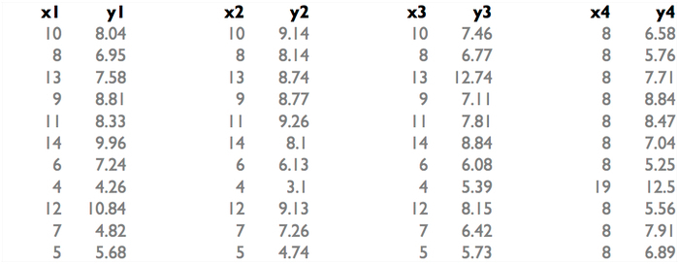
Sample data sets recreated from Anscombe, Francis J. (1973) Graphs in statistical analysis. American Statistician, 27, 17–21
Ask yourself, what can you see in these sets of data? Do any patterns or trends jump out? Perhaps the sequence of eights in the fourth set? Otherwise there's nothing much of interest evident.
So what if we now visualize this data, what can we see then?
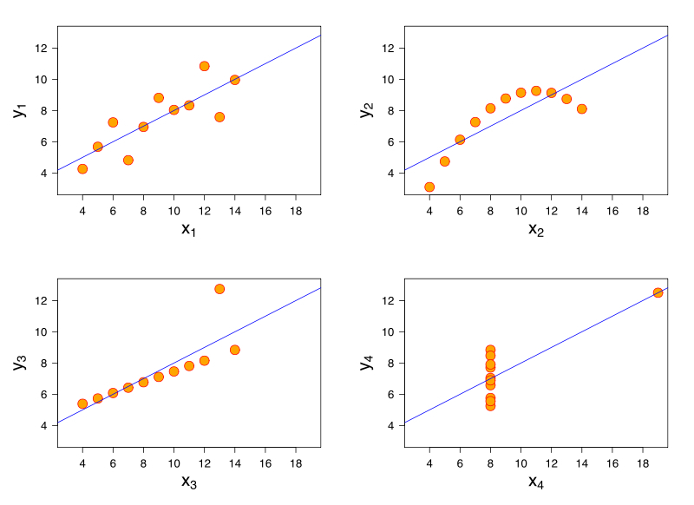
Image published under the terms of "Creative Commons Attribution-Share Alike", source: http://commons.wikimedia.org/wiki/File:Anscombe%27s_quartet_3.svg
Through the previous graphical display, we can immediately see the prominent patterns created by the relationships between the X and Y values across the four sets of data as follows:
- the general tendency about a trend line in X1, Y1
- the curvature pattern of X2, Y2
- the strong linear pattern with single outlier in X3, Y3
- the similarly strong linear pattern with an outlier for X4, Y4
The intention and value of Anscombe's experiment was to demonstrate the importance of presenting data graphically. Rather than just describing a dataset based on a selection of some of its key statistical properties alone, to make proper sense of data, and avoid forming false conclusions we need to also employ visualization techniques.
It is much easier to discover and confirm the presence (or even absence) of patterns, relationships, and physical characteristics (such as outliers) through a visual display, reinforcing the essence of Tukey's quote about the value of pictures.
Data visualization is about a discovery process, enabling the reader to move from just looking at data to actually seeing it. This is a subtle but important distinction.
The bedrock of visualization knowledge
Data visualization is not easy. Let's make that clear from the start. It should be genuinely viewed as a craft. It is a unique convergence of many different skills and requires a great deal of practice and experience, which clearly demands time and patience.
Above all, it requires a deep and broad knowledge across several traditionally discrete subjects, including cognitive science, statistics, graphic design, cartography, and computer science.
This multi-disciplinary recipe unquestionably makes it a challenging subject to master but equally provides an exciting proposition for many. This is evidenced by the field's popular participation, drawing people from many diverse backgrounds.
If we look at this subject convergence at a more summary level, data visualization could be described as an intersection of art and science. This combination of creative and scientific perspectives represents a delicate mixture. Achieving an appropriate balance between these contrasting ingredients is one of the fundamental factors that will determine the success or failure of a designer's work.
The art side of the field refers to the scope for unleashing design flair and encouraging innovation, where you strive to design communications that appeal on an aesthetic level and then survive in the mind on an emotional one. Some of the modern-day creative output from across the field is extraordinary and we'll see a few examples of this throughout the chapters ahead.
The science behind visualization comes in many shapes. I've already mentioned the presence of computer science, mathematics, and statistics, but one of the key foundations of the subject comes through an understanding of cognitive science and in particular the study of visual perception. This concerns how the functions of the eye and the brain work together to process information as visual signals.
One of the other most influential founding studies about visual perception emerged from the Gestalt School of Psychology in the early 1900s, specifically in the shape of the Laws of Perceptual Organization (http://www.interaction-design.org/encyclopedia/data_visualization_for_human_perception.html).
These laws provide an organized understanding about the different ways our eyes and brain inherently and automatically form a global sense of patterns based on the arrangement and physical attributes of individual elements.
Here, we can see two visual examples of Gestalt Laws.
On the left-hand side is a demonstration of the "Law of Similarity". This shows a series of rows with differently shaded circles. When we see this our visual processes instantly determine that the similarly shaded circles are related and part of a group that is separate and different to the non-shaded rows. We don't need to think about this and wait to form such a conclusion; it is a preattentive reaction.
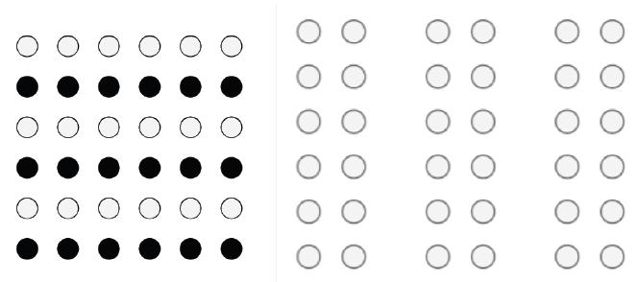
Images republished from the freely licensed media file repository Wikimedia Commons, source: http://en.wikipedia.org/wiki/File:Gestalt_similarity.svg and http://en.wikipedia.org/wiki/File:Gestalt_proximity.svg
On the right-hand side is a demonstration of the "Law of Proximity". The arrangement of closely packed-together pairs of columns means we assume these to be related and distinct from the other pairings. We don't really view this display as six columns, rather we view them as three clusters or sets.
At the root of visual perception knowledge is the understanding that our visual functions are extremely fast and efficient processes whereas our cognitive processes, the act of thinking, is much slower and less efficient. How we exploit these attributes in visualization has a significant impact on how effectively the design will aid interpretation.
Consider the following examples, both portraying analysis of the placement of penalties taken by soccer players.
When we look at the first image, the clarity of the display allows us to instantly identify the football symbols, their position, and their classifying color. We don't need to think about how to interpret it, we just do. Our thoughts, instead, are focused on the consequence of this information: what do these patterns and insights mean to us? If you're a goalkeeper, you'll be learning that, in general, the penalty taker tends to place their shots to the right of the goal.
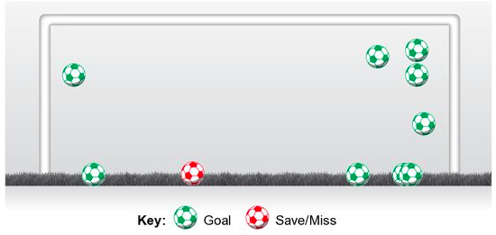
Image republished under the terms of "fair use", source: http://www.facebook.com/castrolfootball
By contrast, this second display's attempt to portray the same type of data presentation causes significant visual clutter and confusion. Rather than using a simple and relatively blank image like the previous one, this display includes strong colors and imagery in the background. The result is that our eyes and brain have to work much harder to spot the footballs and their colors because the data layer has to compete for attention with the background imagery. We are therefore unable to rely on the capabilities of our preattentive visual perception (determined by the Law of Similarity) because we cannot easily perceive the shapes and their attributes representing the data. This delays our interpretative processes considerably and undermines the effectiveness and efficiency of the communication exchange.
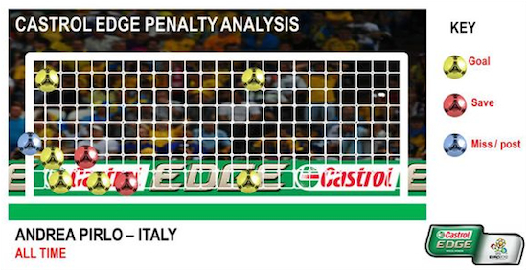
Image republished under terms of "fair use", source: http://www.mirror.co.uk/sport/football/euro-2012-where-italy-will-place-their-penalties-907506
This is just a single, simple example but it does reveal the significance of understanding and obeying visual perception laws when portraying our data.
When we design a visualization, we need to take advantage of the strengths of the visual function and avoid the disadvantages of the cognitive functions. We need to minimize the amount of thinking or "working out" that goes into reading and interpreting data and simply let the eyes do their efficient and effective job.
Through the pioneering studies and development of theories acquired and refined over many years by the Gestalt School of Psychology as well as influential academics and theorists like Jacques Bertin, Francis Anscombe, John W Tukey, Jock McKinlay, and William Cleveland, we now have a greater understanding of how to achieve effective and efficient visualization design.
There is still a great amount of empirical evidence to gather, studies to conduct, and firm answers to unearth, but the wealth of knowledge available to us is a significant help to remove an undue amount of instinct in our design work.
Defining data visualization
It is important now to consider a definition of data visualization. To do this, we first need to consider the main agents involved in the exchange of information; namely, the messenger, the receiver, and the message. The relationship between these three is clearly very important, as this illustration explains:
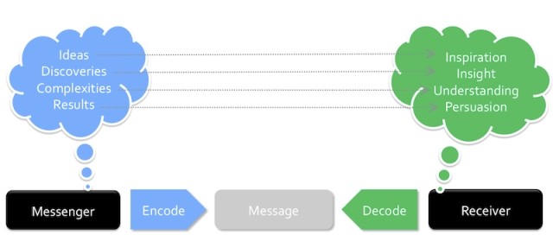
On one side we have a messenger looking to impart results, analysis, and stories. This is the designer. On the other side, you have the receiver of the message. These are the readers or the users of your visualization. The message in the middle is the channel of communication. In our case this is the data visualization; a chart, an online interactive, a touch screen installation, or maybe an infographic in a newspaper. This is the form through which we communicate to the receiver.
The task for you as the designer is to put yourself in the shoes of the reader. Try to imagine, anticipate, and determine what they are going to be seeking from your message. What stories are they seeking? Is it just to learn something new or are they looking for persuasion, something with more emotional impact? This type of appreciation is what fundamentally shapes the best practices in visualization design: considering and respecting the needs of the reader.
The important point is this: to ensure that our message is conveyed in the most effective and efficient form, one that will serve the requirements of the receiver, we need to make sure we design (or "encode") our message in a way that actively exploits how the receiver will most effectively interpret (or "decode") the message through their visual perception capabilities.
From this illustration we can form the following definition to clarify, at this early stage, what we mean by data visualization:
The representation and presentation of data that exploits our visual perception abilities in order to amplify cognition.
Let's take a closer look at the key elements of this definition to clarify its meaning; these are as follows:
- The representation of data is the way you decide to depict data through a choice of physical forms. Whether it is via a line, a bar, a circle, or any other visual variable, you are taking data as the raw material and creating a representation to best portray its attributes. We will cover this aspect of design much more in Chapter 4, Conceiving and Reasoning Visualization Design Options and Chapter 5, Taxonomy of Data Visualization Methods.
- The presentation of data goes beyond the representation of data and concerns how you integrate your data representation into the overall communicated work, including the choice of colors, annotations, and interactive features. Similarly, this will be covered in depth in Chapter 4, Conceiving and Reasoning Visualization Design Options.
- Exploiting our visual perception abilities relates to the scientific understanding of how our eyes and brains process information most effectively, as we've just discussed. This is about harnessing our abilities with spatial reasoning, pattern recognition, and big-picture thinking.
- Amplify cognition is about maximizing how efficiently and effectively we are able to process the information into thoughts, insights, and knowledge. Ultimately, the objective of data visualization should be to make a reader or users feel like they have become better informed about a subject.
The definition that I've put forward here is not dissimilar to the many others articulated by authors, academics, and designers down the years. It is not intended to offer a paradigm shift in our understanding of what this is all about. Rather, it represents a personal perspective of the discipline influenced by many years of experience teaching, practicing, and constantly studying the subject.
The fact that data visualization is such a dynamic and evolving field, with this unique conjunction of art and science shaping its practice, means that a single, perfect, and universally-agreed definition is always going to be difficult to construct. However, this proposed definition should at least help you develop an appreciation of the boundaries of data visualization and recognize when something evolves into a different form of creative output.
Visualization skills for the masses
The following is a quote from Stephen Few from his book Show Me the Numbers:
"The skills required for most effectively displaying information are not intuitive and rely largely on principles that must be learned."
More and more of us are becoming responsible for the analysis, presentation, and interpretation of data. This naturally reflects the explosion in access to data and the value attributed to potential insights that are contained.
As I've already stated, where once this was typically a specialist role, nowadays the responsibility for dealing with data has crept into most professional duties. This has been accelerated by the ubiquitous availability of a range of accessible productivity tools to handle and analyze data.
This means visualization has become both a problem and an opportunity for the masses, which makes the importance and dissemination of effective practice a key imperative.
The quote from Stephen Few will resonate with many of you reading this. If you were to ask yourself "Why do I design visualizations in the way I do?", what would be your answer? Think about any chart or graphic you produce to communicate information to others. How do you design it? What factors do you take into account? Perhaps your response would fall in to one or more of the following:
- You have a certain design style based on personal taste
- You just play around until something emerges that you instinctively like the look of
- You trust software defaults and don't go beyond that in terms of modifying the design
- You have limited software capabilities, so you don't know how to modify a design
- You just do as the boss tells you—"can you do me some fancy charts?"
For many people, the idea of a conscious data visualization design technique isquite new. The absence of any formal coaching, at almost any level of education, in the techniques of visualization means until you become aware of the subject, you have probably never even thought about your visualization design approach.
Before discovering this subject, my own approach to presenting data was certainly not informed by any training or prior knowledge. I'd never even thought about it. Taste and gut-feel were my guiding principles alongside a perceived need to show off technical competencies in tools like Excel. Indeed, I'd like to take this opportunity to apologize for much of my graphical output between 1995 and 2005 where striking gradients and "impressive" 3D were commonplace. The thing is, as I've just said, I didn't realize there was a better way; it simply wasn't on my radar.
In some respects, the reliance on instinct, playing about with solutions that seem to work fine for us, can suffice for most of our needs. However, these days, you often hear the desire being expressed to move beyond devices like the bar chart and find different creative ways to communicate data.
While it is a perfectly understandable desire, just aiming for something different (or even worse, something "cool") is not a good enough motive in itself.
If we want to optimize the way we approach a data visualization design, whether it be a small, simple chart or a complicated interactive graphic, we need to be better equipped with the necessary knowledge and appreciation of the many design and analytical decisions we need to make.
As suggested previously, instinct and taste have got us so far but to move on to a whole new level of effectiveness, we need to understand the key design concepts and learn about the creative process. This is where the importance of a methodology comes in.
The data visualization methodology
The design methodology described in this book is intended to be portable to any visualization challenge. It presents a sequence of important analytical and design tasks and decisions that need to be handled effectively.
As any fellow student of Operational Research (the "Science of Better") will testify, through planning and preparation, and the development and deployment of strategy, complex problems can be overcome with greater efficiency, effectiveness, and elegance. Data visualization is no different.
Adopting this methodology is about recognizing the key stages, considerations, and tactics that will help you navigate smoothly through your visualization project.
Remember, though, design is rarely a neat, linear process and indeed some of the stages may occasionally switch in sequence and require iteration. It is natural that new factors can emerge at any stage and influence alternative solutions, so it is important to be open-minded and flexible. Things might need to be revisited, decisions reversed, and directions changed. What we are trying to do, where possible, is find the best path through the minefield of design choices.
Some may feel uncomfortable at the prospect of following a process to undertake what is fundamentally an iterative, creative design process. But I would argue everyone should find value from working in a more organized and sequenced way especially if it helps to reduce inefficiency and wasted resource.
The design challenges involved in data visualization are predominantly technology related; the creation and execution of a visualization design will typically require the assistance of a variety of applications and programs. However, the focus of this methodology is intended to be technology-neutral, placing an emphasis on the concepting, reasoning, and decision-making.
The variety, evolution, and generally fragmented nature of software in this field (there is no single tool that can do everything) highlights the extra importance of reasoned decision-making, regardless of the richness and power individual solutions can offer.
Another key point to remark on is to emphasize, if it wasn't already clear, that data visualization is not an exact science. There is rarely, if ever, a single right answer or single best solution. It is much more about using heuristic methods to determine the most satisfactory solutions.
On that note, the content of the methodology intentionally avoids any sense of dogmatic instruction, preferring to focus on guidelines over explicit rules; sometimes an ounce of chaos, a certain license to experiment, a leaning on instinct, and a sense of randomness can spark greater creativity and serendipitous discovery.
The methodology is intended to be adopted flexibly, based on your own judgment and discretion, by simply laying out all the important things you need to take into account and proposing some potential solutions for different scenarios.
Finally, as I stressed with my definition of the subject earlier, I'm not suggesting this is a ground-breaking new take on the creative process. It is merely a personal interpretation based on experience and also exposure to the many brilliant people out there who share their own design narratives. It is, though, consistent with how most established observers of the subject would recommend you undertake this task. Moreover, it is an approach that I fundamentally believe works and it has genuinely helped me improve my own work since I've adopted it more deliberately, allowing me to cut through projects with the efficiency and elegance I've always yearned for.
Visualization design objectives
Before we launch in to the first stages of the methodology in Chapter 2, Setting the Purpose and Identifying Key Factors, it is important to acknowledge a handful of key, overriding design objectives that should provide you with a framework to test your progress and the suitability of your design decisions.
Whereas the methodology will introduce a number of key thoughts and decisions at each stage of the process, these objectives transcend any individual step and highlight the intricate issues you have to handle throughout your process.
The key objectives are as follows:
Strive for form and function
The following is a quote from Frank Lloyd Wright:
"Form follows function—that has been misunderstood. Form and function should be one, joined in a spiritual union."
The first objective brings us immediately face-to-face with the age-old debate of form versus function or style over substance. As Frank Lloyd Wright proposed, all the way back in 1908, these are aspects of design that should be combined and brought together in harmony, not at the sacrifice of one or the other. There's room and a need for both.
It is a very difficult balancing act to achieve, as I've already alluded to in the discussion about art and science, but our aim should be to hit that sweet-spot where something is aesthetically inviting and functionally effective.
The designer and author Don Norman (http://www.jnd.org/dn.mss/emotion_design.html) talks about how we're more tolerant about things that are attractive and more likely to want them to perform well. Indeed, there is a school of thought that suggests how we think cannot be separated from how we feel.
Norman goes on to describe how well-executed aesthetics can naturally create favorable emotional and mental responses, but emotional affection can also come from the experience of good usability and the accomplishment of insight. Fundamentally, attractive form enhances function and the function portrays beauty through its effect.
Throughout this book, we will see examples of designs that have succeeded in creating elegance in form and in function. The following image is taken from an animated wind map developed by Fernanda Viégas and Martin Wattenberg. It is a beautiful piece of work, exceptionally well designed and executed but it also serves its purpose as a way of informing users about the wind patterns, strength, and directions occurring across the United States. This is form and function in spiritual union:
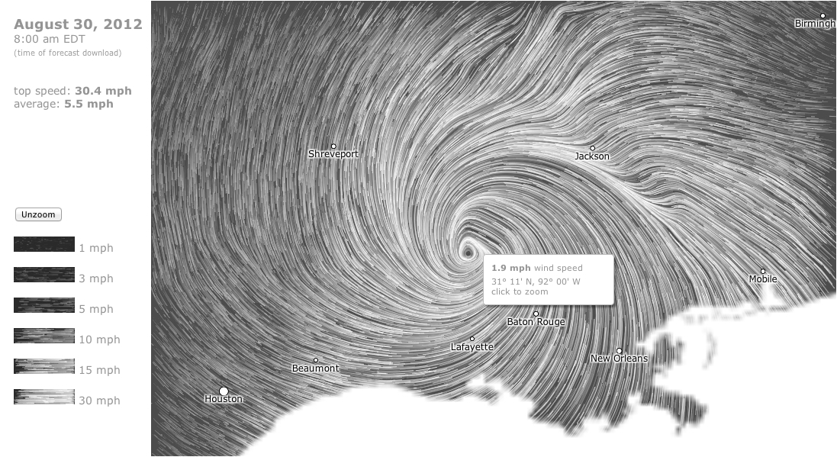
Image from "Wind Map" (http://hint.fm/wind/) created by Fernanda Viégas and Martin Wattenberg
The general advice, especially for beginners, is to initially focus on securing the functional aspects of your visualization. First, try to achieve the foundation of something that informs—that functions—before exploring the ways of enhancing its form. The simplest analogy would be build the house before decorating it, but I wouldn't want to create too much separation between the two as they are often intrinsically linked. Over time, you will be much more confident and capable of synthesizing the two demands in harmony. We shall discuss this in more depth in Chapter 4, Conceiving and Reasoning Visualization Design Options.
Justifying the selection of everything we do
The following is a quote from Amanda Cox (http://vimeo.com/29391942), who works as a graphics editor at the New York Times:
"We're so busy thinking about if we can do things, we forget to consider whether we should."
In many ways, the central idea behind the methodology is encouraging you to determine that everything you do is thoroughly planned, understood, and reasoned.
This particular objective is about recognizing and responding to the scoping information that you will gather at the start of the methodology, to ensure that everything undertaken thereafter serves the purpose of our work and the needs of the audience.
Here, we should consider the idea of deliberate design, which means that the inclusion, exclusion, and execution of every single mark, characteristic, and design feature is done for a reason.
When we reach the stage of designing, concepting, and construction, you should be prepared to challenge everything; the use of a shape, the selection of a color pallet, the position of a label, or the use of an interaction.
In this next example, when displaying a section of a tree-hierarchy work by data illustrator, Stefanie Posavec, every visible property presented is used to communicate data, whether it be the use of color, the arc lengths of the petals, the position and sequence of stems; nothing is redundant and everything is deliberate.
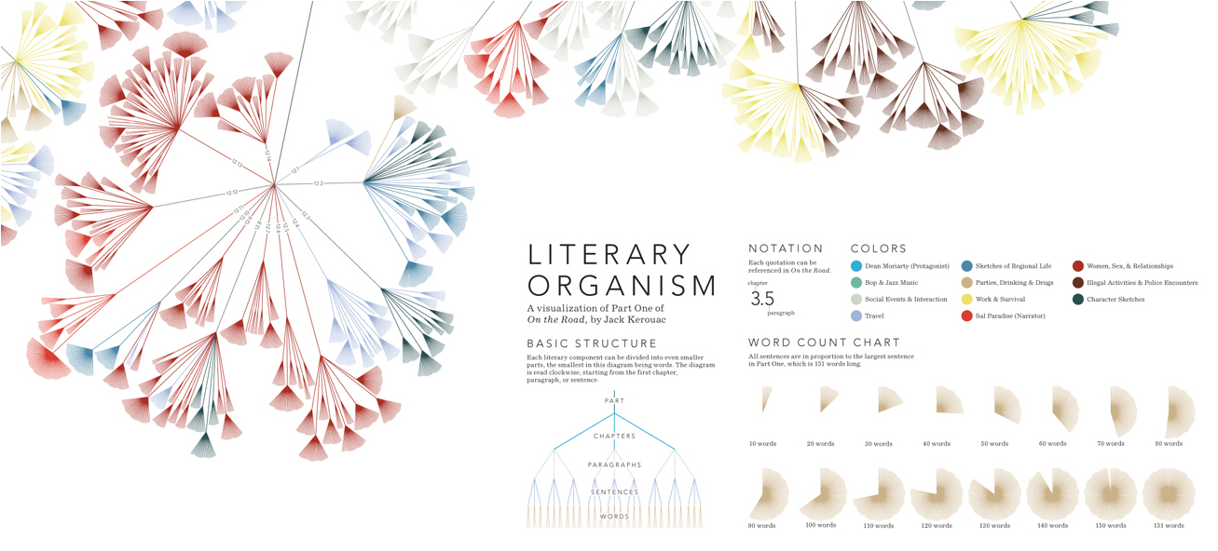
Image from "Literary Organism" (http://itsbeenreal.co.uk/index.php?/wwwords/literary-organism/), created by Stefanie Posavec
It is also important to make sure that any visual property that is included, but does not represent data, such as shading, labels, colors, and axes among other properties, should only be included to aid the process of visual perception, not hinder it.
Furthermore, for interactive and animated visualizations, remember Amanda Cox's quote—"just because you can, doesn't mean you should." Don't succumb to the belief (like I did for many years) of thinking a visualization is a platform solely to showcase your technical competence.
Cluttering visualizations with fancy interactive features is a trap that is easy to fall into and leads to projects that look nice or are impressive technically but fail to serve their intended purpose. Instead, they interfere with the efficiency and effectiveness of the information exchange thus demonstrating a failure to synthesize form and function.
Creating accessibility through intuitive design
The following is a quote from Edward Tufte (http://adage.com/article/adagestat/edward-tufte-adagestat-q-a/230884/):
"Overload, clutter, and confusion are not attributes of information, they are failures of design."
When you next happen to be in a town or city center, take a look around you and observe how often people are confused by and struggle with the basic operation of correctly opening and entering doors into a store. Notice how the accessibility and function of a door—the simple act of opening and walking through it—is often impaired through a lack of intuitive design.
The method of opening a door should be straightforward, but often the aesthetics of features such as stylish door handles means we pull when we should push and we push when we should pull. This is a flaw in the intuitiveness and logic of the design, a failure in perceived affordance—it doesn't do what it looks like it should do.
This idea is an important concept to translate into visualization. As we have already outlined, we are trying to exploit the inherent spatial reasoning and pattern recognition functions of visual perception. We don't want people to have to spend unnecessary time thinking about how to use or how to read and interpret something.
When you are creating a visualization, you are integrating visual design with a subject matter's data. The former is the window into the latter, and it is the design and execution of this window that creates the accessibility.
But it is important to create a distinction between accessibility and immediacy. The speed with which you are able to read or interpret a visualization should be determined by the complexity of the subject and the purpose of the project, not by the ineffectiveness of design.
Sometimes subjects are fundamentally simple and the portrayal of the data is straightforward and intuitive. This in turn means the reader's task of interpreting the data should be relatively easy.
On other occasions, a data framework might be more complex. Your challenge will be to respect the complexity and avoid simplifying, diluting, or reducing the essence of this subject. This might mean something is not immediately easy to interpret. Some visualizations will require effort to be put in, forcing the reader to undertake a certain amount of experiential practice in order for the eye and mind to essentially become trained in reading the display.
Think of it being like muscle memory, but for the eye and the brain. We are so used to reading bar charts and line charts that they have become entrenched and programmed into our interpretative toolkit. But when we are faced with something new, something different or seemingly complex, its not always immediately clear how we are supposed to handle it.
In the following example, we see a demonstration of what is quite a complex data framework. This is an image of a legend that was used to explain how to read an innovative visualization to portray three separate indicators of a movie's success. On the left-hand side of the image is the aggregate reviews (the higher the value, the better) and on the right-hand side of the image are both the budget and gross takings (the bigger the gap, the better):
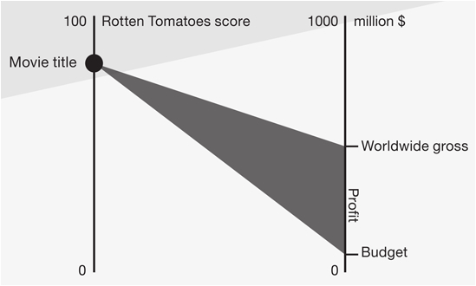
Image from "Spotlight on Profitability" (http://www.szucskrisztina.hu), created by KrisztinaSzucs
It is an unusual representation of data, not something as preprogrammed as the bar or line chart, and so it takes a short while to learn how to read and interpret the resulting shapes formed by the movie data shown across piece. This is absolutely legitimate as an effective approach to visualizing this data so long as the efforts that go into learning how to read it eventually leads the user to understand it.
Take another example, which portrays the key events in a couple of soccer matches showing completed passes (green lines), shots (blue triangles), and goals (red dots) as shown in the following image:

Image from "Umbro World Cup Poster" (http://www.mikemake.com/Umbro-s-World-Cup-Poster), created by Michael Deal
Once the reader has mastered the understanding of what each shape and its position means, these displays provide a powerful and rewarding insight in to the key incidents and the general ebb and flow of each game.
In simple terms, so long as you can avoid all the negative characteristics that Edward Tufte mentions at the top of this section, you should succeed in giving people an accessible route in to the data. Make sure that the efforts needed from the reader or user to understand how to use and interpret a visualization are ultimately rewarded with a worthy amount of insight gained.
Never deceive the receiver
Visualization ethics relates to the potential deception that can be created, intentionally or otherwise, from an ineffective and inappropriate representation of data. Sometimes it can be through a simple lack of understanding of visual perception.
In the following diagram, we see a 2D pie chart and a 3D version. When the eye interprets a graphic like this, what it is actually doing is perceiving the proportion of visible pixels:
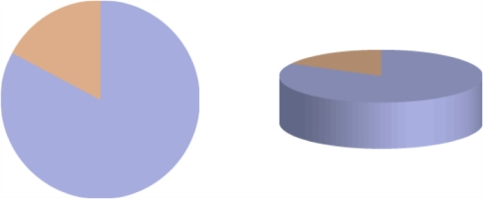
Image from "The Curious Incident of Kevins in Zurich…and other stories" (http://www.researchobservatories.org.uk/EasysiteWeb/getresource.axd?AssetID=38334) by Alan Smith.
On the left-hand side of the diagram, we see a blue segment representing 82 percent and an orange segment representing 18 percent. These are the actual values. However, when we introduce a third dimension on the right—incidentally, a dimension which is purely decorative and has no relationship with data values—our eyes are deceived because we are not capable of easily adjusting our interpretation of the values across this isometric projection. With the introduction of the extra dimension and the visible height of the pie itself, we now perceive 91 percent of the visible area as blue and only 9 percent orange. This is clearly a hugely distorted reading of the values.
Another similar example comes from a Wikipedia fundraising campaign from a few years ago and a progress bar depicting the status of their efforts; as shown in the following screenshot:

Image published under the terms of "Creative Commons Attribution-Share Alike", source: https://donate.wikimedia.org/
As with the pie chart, for a bar chart we perceive the visible pixels as being representative of the values. The label indicates a total of $0.8M USD had been raised (10.7 percent towards target) but if you calculate the actual length of the bar displayed, this occupies 24.6 percent of the overall bar length. Once again, a significant distortion of the truth.
This next example is a demonstration of where aesthetics and style completely hijack a visualization. Here, we have a still showing a 3D bar chart that swooshes impressively onto the screens of those watching soccer on TV in the UK:
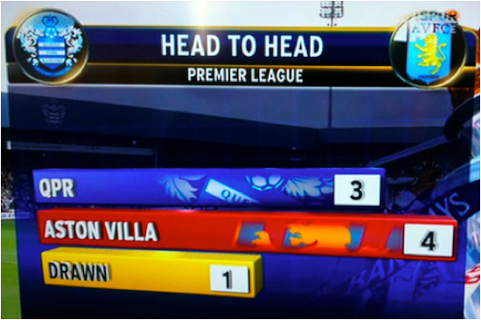
But what have we here? There is a yellow Drawn bar representing the value 1 and this appears to be more than half the length of a red Aston Villa bar representing 4. How can that be?
The designers of this visual have chosen to include the category labels within the bar's length, thus completely distorting the values being represented. Now, this is possibly one of the least interesting statistics you'll come across, and I'm assured the world will not stop turning as a result of this graphical misdemeanor, but it should demonstrate the pitfalls of decoration and overly stylized design.
Obeying visualization ethics is clearly an objective for any project, but really it is just about basic, good practice, respect for your readers, and attention to detail.
Chapter 2. Setting the Purpose and Identifying Key Factors
Chapter 1, Context of Data Visualization, gave us some initial idea about the definition, context, and relevance of data visualization. We learned about the intersection that exists between art and science and outlined the significance of visual perception.
We also discussed the proposed value of a data visualization methodology and, ahead of our design process, learned about some key objectives we need to bear in mind throughout our work.
In this second chapter, we start the design methodology with the vital task of identifying the purpose of your visualization.
Before you undertake any design work, you have to be clear about the motivation behind a project's inception. This involves identifying who it is for and what needs you are trying to fulfill; this has a big influence on the scope of your work.
The second aspect of purpose will take a close look at the intention behind your project and how you define the visualization's function and tone. Once again, we tackle this now so that we can start to shape our decision-making at the earliest possible opportunity.
We then look at identifying and assessing the impact of the additional key factors that will have an effect on your project. This will help you surface all the restrictions, characteristics, and requirements surrounding your project that will determine how you tackle it.
Finally, we will consider in more depth a particularly influential matter: the skills, knowledge, and general capabilities that are necessary to accomplish an effective visualization solution.
Clarifying the purpose of your project
We start at the very beginning. Why are we doing this project? What is its purpose?
These might seem like blunt questions to ask but it is so important to establish this type of clarity before we go much further. You might think: "please can we just get on with it?" and you're probably itching to get on to a computer and start playing with some data, but these initial few stages of this methodology are very deliberately designed to get you in to the habit of this type of reflective or analytical assessment.
If you look at a dictionary definition for "purpose", it will usually say something similar to: reason for existing, intended effect. These two dimensions neatly capture the focus of our definition work at this point in the journey.
The reason for existing
Let's start with the reason for existing. This is about recognizing the trigger behind the project or the origin from where it emerged. This gives us an idea of the scope and context of what we are about to undertake, how much creative control we might have, whether we've been encouraged to follow a particular creative direction and what ideas have already been formed.
A project will typically form in one of following two ways: you've either been asked to do it or you've decided to do something yourself. You might think that's obvious, but these are very different scenarios for working creatively.
If it's the former, a project that's essentially been commissioned, you will have most likely been given the task by a colleague or a manager or from a client you are working with/for. A further source may be something like an invited assignment such as tendering for some work or even entering a design contest.
You will have received or read a brief and possibly had some initial discussions that provided you with an outline of the requirements. You might have some instructions and a general idea of what they are seeking.
From gathering this contextual information, you should have a reasonably clear idea about the background to the project, what you're being asked to do, why you're doing it and who you're doing it for. It may be quite loose and open-ended, in which case you've got a greater range of possibilities, but it's more likely to be quite defined and specific.
You've probably also experienced the pain of hearing some of the initial ideas flying round, as your creative soul dies a slow death in response to requests such as "cool charts" and "make it fancy" or "I want an Edward Tufte style piece".
By contrast, for a project that is self-initiated, things are very different. Maybe, it is a dataset that you've found about a subject that interests you, maybe you've decided to test out some theory or you've been chatting to (or, more truthfully, drinking with) mates and have struck on a particular curiosity that simply must be explored.
This scenario is a completely self-defined, self-determined, and more flexible context than that of a commissioned project. It doesn't involve a client, or a brief, or a set of instructions, or restrictions on scope, timescales, or audience—you've got a blank canvas to follow the scent of what it is that motivated you in the first place.
A very different proposition to a commissioned project and an important distinction that needs to be established.
The intended effect
Whatever the motivation and background for doing the project, you will inevitably start to form a vision in your mind of what you might be about to create, how it might look, and what it might do. This is a natural instinct as you embark on a creative process.
This vision might leap into your mind the minute you start to think around the task, regardless of its origin. You might recall certain influential or inspirational works that you've seen in the past or remember concepts you previously developed that went no further.
It's important to capture these thoughts if they do form. Make sure you keep notes, in your sketchbook, on your tablet, or on a cigarette packet—it doesn't matter where, just do it before you forget. While we don't want to be closed off and commit ourselves to the pursuit of the first thing we think of, these instinctive thoughts could prove valuable later on.
It's from these sparks of creativity that we shift our thoughts to the second dimension of purpose, which is the intended effect of the visualization project. This is a really critical matter, so we're going to take a bit of time to get our heads around it.
Here's why it's so important to be thinking about all this in such depth. Even though it is very early in the process, the decisions, or more accurately, the definitions we form now, will have a strong bearing on the creative direction we pursue. It's not doing anything that can't be reversed or refined further down the line but it is important to establish as much focus and clarity about our intentions now so that we can reduce the complexity of the challenge and the potential variety of the solution.
The choices we make now will also influence the resources (technical and personnel) we might need to deploy, but we shall look more at this towards the end of the chapter.
Remember in Chapter 1, Context of Data Visualization (you should do, after all it's only been a few pages) we saw a definition for data visualization that proposed the overall aim as being to "amplify cognition" or, in other words, make someone feel better informed. That was a deliberately equivocal aim because there are many different motivations and reasons for creating a data visualization.
Consider the following sample collection of phrases, which articulate a variety of viable intentions behind creating a visual representation of data:
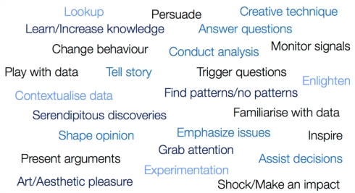
If we look closely at the verbs and the overall language being used, we can start to recognize quite a range of differing effects that might be sought.
For example, a visualization to assist with the monitoring of signals or facilitating a visual lookup of data will be very different from a design that is intended to grab attention or change behavior. Similarly, presenting arguments and telling a story is a very different setting to conducting analysis or 'playing' with data.
What we have here is evidence of different dimensions of intent. Identifying your intended effect means deciding what you're aiming to achieve and how you're going to achieve it.
At the root of this is an appreciation of your target audience, one of the most important considerations we have to take into account. During this initial definition and scoping work, it is crucial to profile your intended readers/users.
These are the people who we are serving and so we need to recognize what type of engagement they are likely to require, for example:
- Is it a boardroom environment with a small collection of senior colleagues who have existing domain subject knowledge?
- Is it a large range of customers, covering all social demographics but potentially representing a captive audience for the subject matter?
- Is it a completely global, undefined audience with no influencing characteristics—in a sense no specific target, just anyone and everyone?
- Is it a one-to-one exchange with a manager?
- Is it an entirely personal engagement between you and data—a desire to learn about and explore data yourself?
Clarity of what and who your target audience is will help shape your intent and from this we'll be able to define two very important dimensions: the function and tone of your visualization project.
Establishing intent – the visualization's function
The intended function of a data visualization concerns the functional experience you create between your design, the data, and the reader/user.
If we revisit the range of phrases presented earlier, it is possible to form three separate clusters or categories of function. While there is always a chance of slight overlap, there will be a significant difference in your design choices depending on whether the function of your visualization is to:
- Convey an explanatory portrayal of data to a reader
- Provide an interface to data in order to facilitate visual exploration
- Use data as an exhibition of self-expression
When the function is to explain
Explanatory data visualization is about conveying information to a reader in a way that is based around a specific and focused narrative. It requires a designer-driven, editorial approach to synthesize the requirements of your target audience with the key insights and most important analytical dimensions you are wishing to convey.
There are many ways in which you can "explain" data. It could be through an information dashboard in a corporate setting, where you are conveying the latest performance figures and highlighting the key issues requiring attention. It might be a graphic in a newspaper, explaining the complexity and severity of the problems around the economic crisis. It could be an animated design to display patterns of population migration over time. It could also be a physical or ambient visualization designed to draw attention to the sugar content of certain drinks.
The end result is typically a visual experience built around a carefully constructed narrative. Your objective as the designer is to create a graphical display, made accessible through intuitive, visual design that clearly portrays the narrative you are seeking to impart.
Here is an example of an explanatory visualization, based on a chart type called a Sankey diagram, which portrays analysis of the top ten freshwater-consuming countries and the breakdown of its usage:
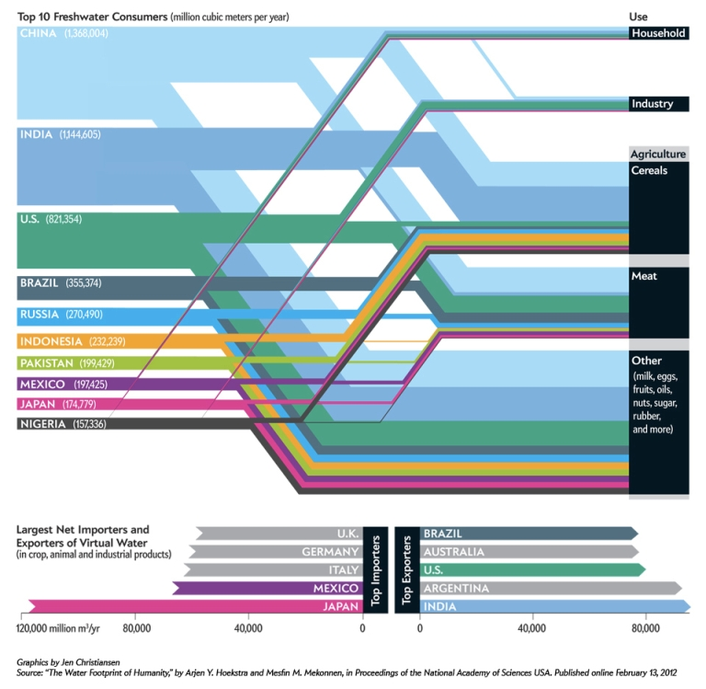
Image from "Top 10 Freshwater Consumers" (http://www.scientificamerican.com/article.cfm?id=water-in-water-out) created by Mark Fischetti and Jen Christiansen, Scientific American, June 2012. Reproduced with permission. Copyright © 2012 Scientific American, Inc. All rights reserved.
Note that explanatory visualizations are not limited to just being static in design. Indeed, some of the most impactive, narrative-driven pieces can be framed within an interactive or animated construction.
When the function is to explore
Exploratory data visualization design is a slightly different matter compared to creating an explanatory piece. Here, we are seeking to facilitate the familiarization and reasoning of data through a range of user-driven experiences. In contrast to explanatory-based functions, exploratory data visualizations lack a specific, single narrative. They are more about visual analysis than just the visual presentation of data.
Exploratory solutions aim to create a tool, providing the user with an interface to visually explore the data. Through this they can seek out personal discoveries, patterns, and relationships, thereby triggering and iterating curiosities. It also opens up the possibility for chance or serendipitous findings caused by forming different combinations of variable displays.
Really, the key feature that differentiates an exploratory piece from an explanatory piece is the amount of work you have to do as a reader to discover insights. For explanatory pieces, the designer should do the hard work and create a clear portrayal of the interesting stories and analysis from a dataset. An exploratory piece will be more about the readers doing the analysis themselves, putting the effort in to discover things that strike them as being significant or interesting.
In the following image, we see a scatterplot matrix visualization: a method used to reveal correlations across a multivariate dataset, enabling the eye to efficiently scan the entire matrix to quickly identify variable pairings with strong or weak relationships. This is a perfect example of an exploratory visualization design:
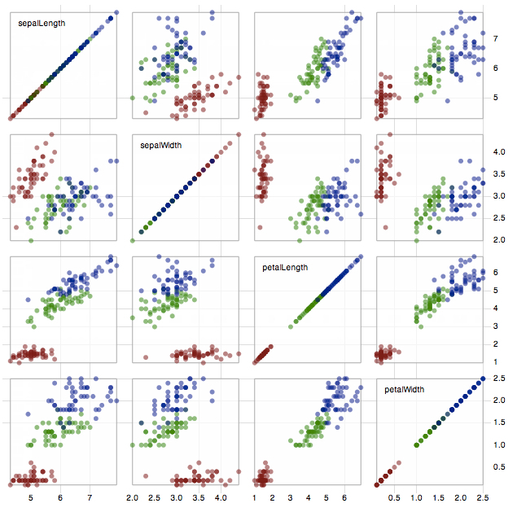
Image from "Scatterplot Matrix" (http://mbostock.github.com/d3/ex/splom.html), created by Mike Bostock.
Exploratory visualizations are not limited to being interactive. Visual analysis can be facilitated through static portrayals of data. The previous example is actually interactive but a static version would still offer a discovery of the relationships and patterns of the dataset.
That said, it is fair to say that in order to create a truly exploratory experience, interactivity does introduce the potential for so much extra functionality to help immerse the user into a dynamic, problem-solving challenge.
Features such as filtering, sorting, brushing (selecting or isolating certain data values), variable adjustment, and view modification are just some of the important ways you can help a user investigate data. We'll discuss more about interactivity in Chapter 4, Preparing and Familiarizing with Data.
It is also worth highlighting that while explanatory visualization is primarily created for others, exploratory data and the process of visual analysis can be as much for your own discovery purpose as it is for others. It is clearly a particularly relevant function for scientists, for example, to find patterns and unearth key findings in research work before the publication of results (which would then require the use of explanatory-based visual evidence).
When the function is to exhibit data
The final classification of intended function is in some respects a controversial one, because including the exhibiting of data as an intended function of visualization will not be consistent with many people's definition of data visualization.
We're not talking controversy on the level of a political scandal. Let's put it into some perspective: within the context of this field, this is a big deal and the cause of so much debate.
As with any attempt at classification, there is a spectrum of variety within and so clear boundaries are difficult to establish and very much open to personal interpretation.
We are talking here about designs that use data as the raw material, but where the intention is perhaps somewhat removed from a pure desire to inform. Rather, the objective is closer to a form of exhibition or self-expression through data representation. This genre of work embodies the term "data art".
Data art is characterized by a lack of structured narrative and absence of any visual analysis capability. Instead, the motivation is much more about creating an artifact, an aesthetic representation or perhaps a technical/technique demonstration. At the extreme end, a design may be more guided by the idea of fun or playfulness or maybe the creation of ornamentation.
This particular strand of data visualization is contentious simply because it challenges those seeking to identify the boundaries of this field and its proximity to other disciplines such as graphic design, generative design, or creative art.
In the following example, we see an example of data art (as defined by the creator himself) that visualizes all the adjectives used in Cormac McCarthy's book The Road. The adjectives are arranged radially in alphabetical order and each line represents a timeline of the book, beginning at the perimeter:
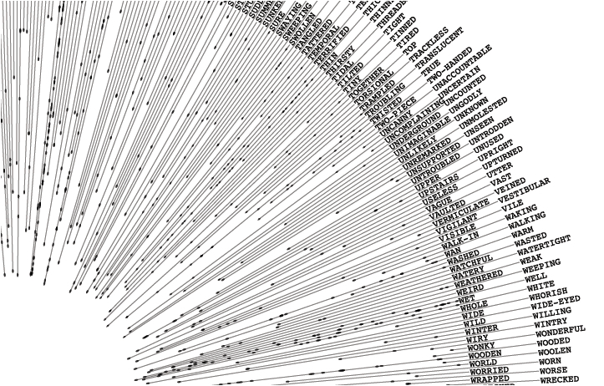
Image from "Adjectives of The Road" (http://distantshape.com/the_road.html), created by Kemper Smith.
The effect is an interesting artifact to look at and its construction is representative of an impressive technical or algorithmic solution, but its primary intent is not to easily allow us to learn about the language in the book. I would personally position this right on the boundary between an exploratory visualization (static, but allowing readers to look up combinations of adjectives and see patterns) and data art.
We characterized explanatory visualization as a single visual experience and exploratory as a numerous but finite set of experiences. By contrast, the range of reactions to exhibition-type designs has a more open and unlimited potential. It aims for and triggers more of an aesthetic reaction, which means our emotional connection and interpretation can vary significantly from one person to the next.
Establishing intent – the visualization's tone
Earlier, we looked at a collection of different phrases that articulate realistic intentions for creating a data visualization. We've just proposed three classifications for how you might organize these terms according to their function.
There will sometimes be an overlap between these otherwise distinct categories, but you should be able to determine relatively clearly where your work intends to fit on the scale between explanation, exploration, and exhibition.
Setting the function is just one part of the "intent" equation. The clarity of your potential design pathway will be much more apparent as we now consider the second dimension of intent—tone.
Establishing a suitable tone goes beyond function and more towards the style of the design experience. It concerns the type of stimulus or desired emotional response that you are trying to create. It is therefore important for you, as the designer, to be able to reason what sort of design will achieve that tone.
With this type of judgment to make, you will inevitably find yourself juggling creative and scientific perspectives. This dynamic poses a significant challenge for any data visualization designer to reason and resolve. Indeed, the design objectives outlined at the end of the previous chapter highlight the intricate issues you have to handle.
I've alluded to the debates and arguments around data art, well this subject inspires the most prominent dividing lines and debates that exist within the field revealing the occasionally awkward and misunderstood relationship between art and science, the pillars of this field.
While it is possibly a crude generalization, the standpoint of the science side is characterized as being concerned with preserving the efficiency and accuracy of judgments derived from a visualization. Variations in data representation that steer away from this goal are believed to reduce the quality and effectiveness of a visualization.
On the other side, the artistic section of the community can be viewed as being concerned with experimentation, finding creative expressions of data, and new aesthetic connections with an audience. Practitioners in this cohort, typically, will have arrived in the field from a strong, design-led or computer science background.
For the rest of us, somewhere in the middle, we find ourselves either holding hands with both sides, following the direction of the wind from one day to the next, or simply sat on a fence without any strong favor towards either side.
So how can we rationalize the role of these two very different, opposing perspectives and beliefs? In my view, the latter enhance the field by demonstrating what can be achieved through the aesthetic and technological creativity. The former help us understand what we should do through the pursuit of evidence and observation of rules around human cognition and visual perception. We need visualizations that look appealing and we need visualizations that perform well.
However, sometimes there has to be mutual recognition that for different scenarios there might be good reason for leaning more towards one direction than the other.
Let's look at the language of two potential motives behind creating a data visualization:
- "We need a chart to help monitor…"
- "We need to present this in a way that persuades people…"
Here, we have two situations both aiming to better inform a reader or a user, but the intended effect or outcome from the experience will be different.
The reaction of a user reading, for example, a dashboard full of bar charts and line charts to help monitor monthly performance will be quite analytical and pragmatic in style. It is unlikely to involve or stir much emotion (unless things are suddenly and unexpectedly plummeting). The style of the visualization design will be consistent with the intended nature of this particular type of engagement, probably quite sober and with an emphasis on the precision of perception.
Compare that with the intended impact of a presentation that depicts how many lives could be saved if a charity was able to achieve a certain level of fundraising. The setting and intent will be more about persuasion making it emotionally charged. It will need to attempt to create an experience that is much more personal and more impactive.
Here, we see potentially two ends of a spectrum for judging the right tone. Yet they fundamentally share the overall motivation of wishing to inform people about a subject through the visual representation of data.
One scenario would achieve this in a relatively pragmatic style, influenced by a desire to optimize the efficiency and accuracy of interpretation. The other would be judged as effective if it evoked a suitably positive emotional response to the data story.
We can therefore describe tone as being a continuum from a pragmatic or analytical portrayal through to a more emotive or abstract concept.
Pragmatic and analytical
The following is a quotation from Jock Mackinlay (http://hci.stanford.edu/courses/cs448b/f10/lectures/CS448B-20100923-DataAndImageModels.pdf):
"A visualization is more effective than another visualization if the information conveyed by one visualization is more readily perceived than the information in the other."
This quote perfectly captures the priority and intent behind pragmatic or analytical visualizations. Some might term them simple or boring but that is short-sighted and lacking in appreciation for the setting in which these types of data portrayal is vital.
Designs that fit this classification will often involve data being represented through the use of bar charts, line charts and dot plots, for example. Stylistically, they will be characterized by a rather clinical look-and-feel that is consistent with the next sample image, taken from a project analyzing Olympic results over the years:
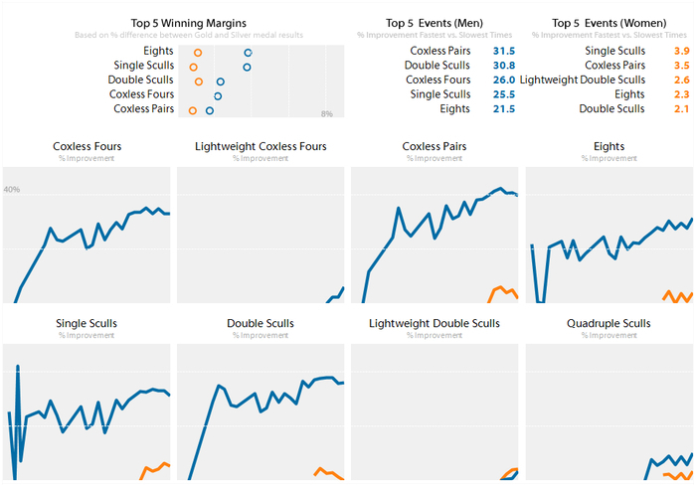
Creating a visualization with a pragmatic tone is about recognizing a need for a design that delivers fast, efficient and precise portrayals of data. Typically, you will have a captive audience, a readership who want to or need to interact and learn from the data. This could be a corporate environment, where people need to simply learn about recent performance of operational activity or undertake visual analysis to discover potentially revealing patterns.
In these cases, there is no value placed on attempting to draw attention to the visualization, or trying to encourage somebody to read or interact with a graphic by employing aesthetic novelty. Furthermore, it's not about trying to inject any emotional or metaphorical connection with the data stories presented.
The purity and impact of its function—the satisfaction that comes from an efficient intake of understanding—fulfils the aesthetics of the charting methods deployed. Therein lies the elegance of pragmatic work.
Emotive and abstract
The following is a quotation from Chris Jordan, TED2008 (http://www.ted.com/talks/chris_jordan_pictures_some_shocking_stats.html)
"I have a fear that we aren't feeling enough, we aren't able to digest these huge numbers."
At the other end of the spectrum are visualizations where the tonal intent is much more emotive and/or abstract in form.
Sometimes you just want to and need to move beyond bars, straight lines, and right angles and more towards curves, circles, and other bendy things. As we will see in Chapter 4, Preparing and Familiarizing with Data, there are consequences to this choice, in respect of the known reduction in the accuracy of value perception this will cause. That is a sacrifice you as the designer need to juggle and justify.
Abstract visualization, in terms of its tone, is more about creating an aesthetic that portrays a general story or sense of pattern. You might not be able to pick out every data point or category, but there is enough visual information to give you a feel for the physicality of the data.
This next image is taken from a project to visualize the global airline transportation network consisting of all commercial flights worldwide. The routes highlighted are those flights in and out of Toronto Pearson airport. The project was designed to assess the threat of infectious diseases.
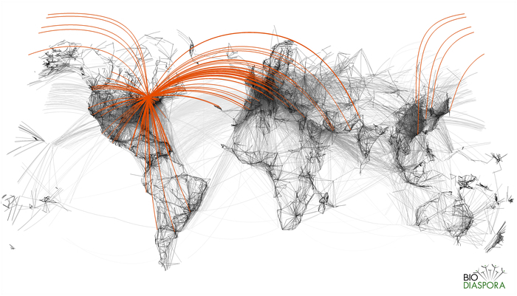
Image from "Toronto Flight Lines" (http://www.biodiaspora.com/) created by Bio.Diaspora 2012
The design does not intend to offer an analytical summary of air travel statistics. Instead it creates a more immersive experience in to the data, offering a visual interface to establish a greater sense of how interconnected the world is through air travel. It causes us to imagine just how easy it could be for diseases to spread across the globe in a short period of time.
For more emotive visualizations, you might be seeking to generate a different type of emotional connection with the design. This connection comes both at the start of the engagement—creating attraction and appeal—as well as after the engagement—the outcome.
In contrast to pragmatic works, as we described in the introduction, here we might be seeking to achieve impact, to emphasize issues, and perhaps to engender shock. We might also seek to generate a certain amount of visual attention through novelty and innovation in a way that more pragmatic approaches would not be able to achieve.
In the following image, we see a section taken from a newspaper infographic that depicted Iraq's bloody toll. While the chart method is nothing more complex than an upside down bar chart, the tone is very impactive and metaphorically emphatic, creating a strong emotional impact to the story it portrays:
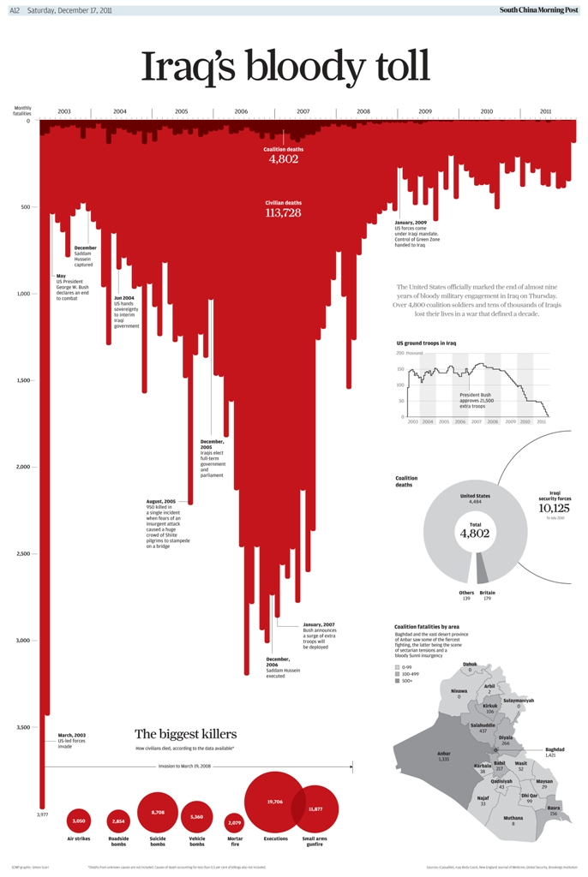
Image from "Iraq's Bloody Toll", published in the South China Morning Post on Saturday, December 13, 2011 (http://graphics-info.blogspot.hk/2012/09/malofiej-20-look-at-our-participation.html), created by Simon Scarr.
Of course, it is important not to stretch the functional and tonal responsibility and capability of visualization too far. This is where any hype and disproportionate expectation about the potential impact of data visualization can be misplaced.
Data visualization is a means to an end, not an end in itself. It's merely a bridge connecting the messenger to the receiver and its limitations are framed by our own inherent irrationalities, prejudices, assumptions, and irrational tastes. All these factors can undermine the consistency and reliability of any predicted reaction to a given visualization, but that is something we can't realistically influence.
All we can do is form a best judgment about where on the continuum of design style, from a pragmatic experience through to an emotive one, the purpose of our data visualization will be most suitably defined. The ultimate responsibility for what happens beyond the visualization engagement sits with the reader or the user.
Key factors surrounding a visualization project
The following is a quotation from Edward Tufte's book, The Visual Display of Quantitative Information:
"Most principles of design should be greeted with some skepticism... we may come to see only through the lenses of word authority rather than with our own eyes."
While establishing the purpose of the visualization project sets the desired tone of the design and its function, there are inevitably many other factors that will have a significant influence on the shape and direction of our visualization design.
It is especially important to identify and recognize the impact of the contextual conditions, within and around your project that will affect what you can and can't achieve and how you might achieve it.
This list of factors may seem quite obvious and fairly rudimentary, but if we wish to eradicate the likelihood of misjudgments or misunderstandings, and maximize the efficiency and effectiveness of the process, we need to nail them early on.
There is simply no point waiting until it is too late to consider these, because by then you will have already followed a certain path and spent valuable time and resources on your work.
Here are some of the most important factors to consider and to evaluate their potential impact:
- The aim: As we have seen already, there are different origins and triggers for a project. We mentioned the self-initiated ones as being almost free of external constraint and essentially framed by our own capabilities and intentions. The important thing worth reinforcing here is the need to take responsibility when a project involves a brief, commissioned by a client or a colleague. You must demonstrate excellent communication skills to ensure you seek and gather as much of an understanding as possible of what it is they are aiming to achieve. Sometimes, you might be provided with a very open brief because a client may not even know what it is they are seeking. In these situations, your responsibility needs to extend to assist them in the scoping and requirements of the work. On other occasions you will be asked to create something that goes against your general practice (for example, the subject matter or requested style) or it might even be simply impossible to deliver (perhaps due to the desired design or available resources). Here again your communication skills are going to be required to manage the expectations. It is easy to be shy and delay asking vital questions but this will only cause you pain later.
- Time pressures: Common to just about every commissioned design project will be the pressure of time and deadlines. Most projects have clear timescales, from in-day quick turnaround pieces to longer-term grand projects. The challenge of maintaining objective creativity in the face of diminishing time is something that will severely test designers of all experiences. Whatever your situation, you have to use your time effectively and that's where value will come from following the tactics in this methodology. Plan your work and create a balanced layout of the things you need to accomplish, so that you avoid disproportionately spending time on tasks that are less important than others. Often you will find yourself undertaking a visualization project in parallel with many other commitments. Not only will your capacity be limited, the momentum and duration of your focus will be impacted. This is where project management skills come to the fore as well as a realistic appreciation of what you should and shouldn't commit to undertaking. It also highlights the importance of keeping notes so that you can move seamlessly between projects and not lose track of your thoughts, ideas, or progress.
- Costs: The issue of financial resource will unquestionably emerge, especially for large-scale projects. Costs will significantly influence the time you are able to commit to a project, the scope for bringing in additional collaborators, and the range of tools or technical resources you might be able to utilize. Once again, the planning and preparation stages will be invaluable to surface all potential issues around financial matters.
- Client pressures: Aside from time pressures, you need to anticipate and reduce the impact of potential unexpected pressures and interruptions coming from your client or colleagues. This might be changes in requirements, new demands, interference in the design solution, and generally annoying things that get in the way of your progress. A further manifestation of the pressure that can come from clients is the insistence on observing organizational visual or brand identities, layout rules, editorial guidelines, and technical frameworks. All of these will shape the scope of your design choices. You have to be prepared for and capable of managing this relationship, and the mutual expectations, effectively so always be open with your client, keep them regularly updated with progress and, where applicable, involve them in the key decision moments throughout the process.
- Format: From a design perspective this will be a significant influencing aspect. Are you creating a static or an interactive design? Maybe it's a multifaceted project and you are looking to create both. If it is an interactive design, what platform do you need to achieve compatibility with? Will it be for the Web, a tablet, and/or smartphones? If it is a static design, will it be a small graphic in a publication, a full-page spread, or a large poster display? Maybe it will be a video animation or an ambient display out in the wild, or a large touch screen installation in a museum. This is a vital consideration that needs to be cleared up at the earliest possible stage. Another factor to take into account will be the likely frequency of the project—is it a one-off piece or will it be something that needs to be replicable and/or scalable? That could hugely affect what you can or can't deliver.
- Technical capabilities: Aside from your own technical capabilities, what are the technical resources to which you have access? For example, are you limited to free tools or can you access more premium software? Do you have the most appropriate technical infrastructure, such as server speed and capacity if it is an online project? Depending on your format choices, what frameworks are you going to deploy, what browsers do you need to have it working on, what backend database technologies are you going to require? This is a wide-ranging and very technical set of decisions that will likely require a specialist technician to determine.
- The "eight hats" of data visualization design
- The final scoping issue to consider at this stage of your visualization design project is an assessment of your personal capabilities and those of any collaborators that you involve in the work. What skills and knowledge do you collectively possess or lack? This is a big issue for many, so we need to spend the remaining pages of this chapter looking at it closely.
- The demands on a visualization designer in terms of capability are many, reflecting the truly multidisciplinary nature of the subject. The convergence of different ingredients introduces a wonderful richness and variety of issues to be concerned with, but it can equally present quite a challenge for people looking to master the subject.
- For many, the prospect of trying to acquire the necessary array of knowledge and skill across the entire range of capabilities is something that can be intimidating or at least exist as a perceptual barrier. There is a sense that to be successful you need to be some sort of superhero.
- Taking an analytical look at the range of required capabilities reveals a role and need for many types of people, which can of course be fulfilled by a number of people or just one.
- These are proposed as the "eight hats of data visualization design". Influenced by the concept of Edward de Bono's six thinking hats, which related to the different thinking perspectives we should try to occupy when tackling complex problems, this is an attempt to organize the different attributes required to accomplish success in visualization.
- It should help you recognize where you fit it in to the spectrum of duties and responsibilities, helping you identify your strengths and your weaknesses accordingly. You may then choose to address these weaknesses personally or plug the gaps with support from others.
- The initiator
- The initiator is the leader, the person who is seeking a solution to the task as per the brief or self-initiated curiosity. The hat is that of an explorer; they want to explore data and different design avenues to find answers to problems or evidence to serve their researcher mindset. The initiator will be responsible for much of the considerations covered in this chapter. They will establish the functional and tonal direction of the project, as well as identify and profile the target audience. The initiator will also define other parameters such as the intended format/platform of the solution and some of the key technological issues.
- The data scientist
- The data scientist is characterized as the data miner, wearing the miner's hat. They are responsible for sourcing, acquiring, handling, and preparing the data. This means demonstrating the technical skills to work with data sets large and small and of many different types. Once acquired, the data scientist is responsible for examining and preparing the data. In this proposed skill set model, it is the data scientist who will hold the key statistical and mathematical knowledge and they will apply this to undertake exploratory visual analysis to learn about the patterns, relationships, and descriptive properties of the data.
- The journalist
- The journalist is the storyteller, the person who establishes the narrative approach to the visualization's problem context. Working with the data scientist and the initiator, they are able to establish the key stories and angles with which to slice the analysis. They work on formulating the data questions that help keep the project's focus on its intended editorial path. Building on the initiator's initial sparks of ideas, the journalist will develop a deeper researcher mindset to really explore the analytical opportunities.
- The computer scientist
- The computer scientist is the executor, the person who brings the project alive. With their critical technical capability they are ultimately the ones who will construct the solution. They will also bolster the data scientist with their technical know-how to most effectively and efficiently handle the data gathering, manipulation, and pre-production visualization activities. The breadth of software and programming literacy will have a great bearing on the potential direction and sophistication of the data visualization solution, whether this is created within a tool or through programming.
- The designer
- The designer is the creative, the one, who, in harmony with the computer scientist, will deliver the solution. They have the eye for visual detail, a flair for innovation and style and are fully appreciative of the potential possibilities that exist. However, they also have the necessary discipline to follow the message established by the initiator and taken on by the journalist. They respect the capabilities of the computer scientist in terms of what solutions could be feasible, but themselves have the helicopter-like vision to rationalize and reason what things will work and will not work, and why.
- Their key responsibility is also to be capable of ensuring the harmony of the solution between its form and its function, ensuring it is aesthetically appealing to draw in the reader while fundamentally delivering the intended, communicated message.
- The cognitive scientist
- The cognitive scientist is the thinker in terms of appreciating the science behind the effectiveness of the technical and designed solutions. They have the visual perception knowledge about how the eye and the brain work most effectively and efficiently. They also have deep knowledge about concepts such as the Gestalt Laws, communication theories, color theories, and human-computer interaction principles. Additionally, they are able to inform the design process in relation to the complexities of how the mind works in terms of memory, attention, decision-making, and behavioral change.
- The communicator
- The communicator is, naturally, concerned with the communication side of the project. With their hard hat on, they act as the negotiator and presenter, operating at the client-customer-designer gateway, helping to inform all those who are involved on progress, requirements, problems, and solutions. The communicator needs to be close to all stages of the process, understanding requirements, appreciating restrictions, recognizing possibilities, and then ultimately launching, publicizing, and showcasing the final work. An ability to articulate and explain matters to different types of people, technical and non-technical, and be capable of managing expectations and relationships is vital.
- The project manager
- This final role is essentially that of the manager or coordinator, the person who does much to pick up many of the unpopular duties to help bring the whole project together. They manage the project's process and its progress, ensuring it is cohesive, on time, and on message. They understand the brief and identify/manage all the key factors surrounding the project. Ultimately, this role is required to ensure things get finished, so they need to have an eye for detail, the commitment and patience to check everything and they should also be concerned with integrity matters around visualization ethics.

